Design Document – Nut Jump

## By Amy Liang

## Game Description

Nut Jump is an arcade action game based off the Neopets mini-game, [Hasee Bounce](http://www.neopets.com/games/game.phtml?game_id=368). The objective of the game is to collect as many floating nuts as possible within the 60-second time limit by controlling the two squirrel brothers. Various types of nuts are spawned that reward a different amount of points.

The two squirrel brothers take turns jumping from a trampoline to a branch above. As one brother falls onto the trampoline, the rebound launches the other brother into the air. The user may only control one squirrel at a time.

Each nut is given a randomized type, speed, location, and direction. A total of 12 nut types exist. The more uncommon the nut is, the more points it provides. The most common nut gives only 1 point, while the rarest nut awards a whopping 50 points. A special type of nut, called the time nut, gives the user 2 points and also adds a 3-second time bonus. If the user has collected 2 time nuts, the third nut will provide 10 seconds instead, and the time bonus counter will reset.

The game comes to an end when the timer reaches 0. Based on the user’s score, a sad, normal or happy ending screen is displayed. From then on, the user may choose to screenshot their score for bragging rights, start a new game or quit.

## Instructions for Play

To begin, double click “Nut Jump.py” to open the file and run the program by pressing F5.

Once the game has been opened, read the instructions by left mouse clicking the “instructions” button or dive right into the game by clicking the “play” button.

A 3-second countdown will commence to prepare you for the game.

From then on, you can control the squirrel on the branch with the left and right arrow keys. Press the “j” key on the keyboard to jump from the branch. The brothers may also be moved left and right while airborne. A red or blue indicator is displayed above the squirrel that is being controlled for clarity.

Try to catch as many nuts as possible within the 60-second time limit. Be aware that certain nuts reward higher points and that time nuts provide a time bonus.

After the timer reaches 0, the game is over. You may begin a new game by clicking “play again” or you may quit by clicking the “quit” button.

## Sketch of Game Screen

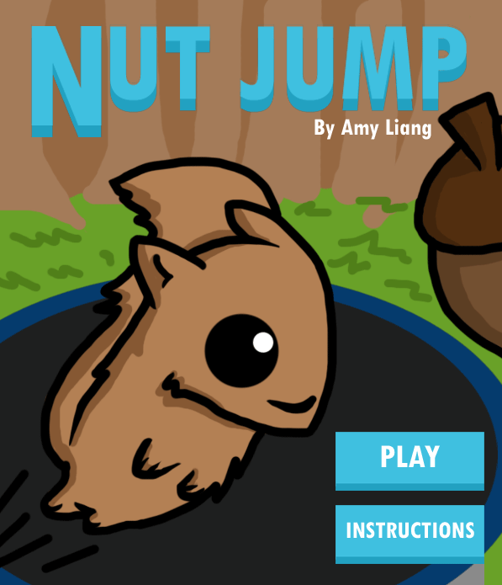 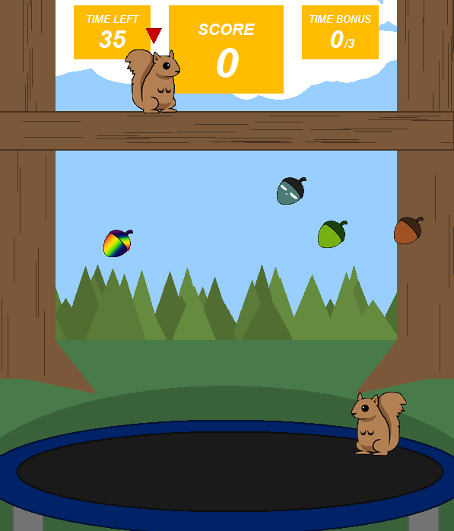

The opening game screen

In-game screenshot 1

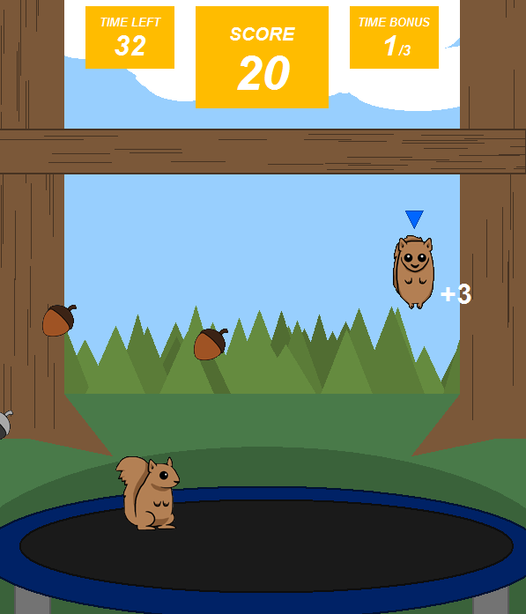 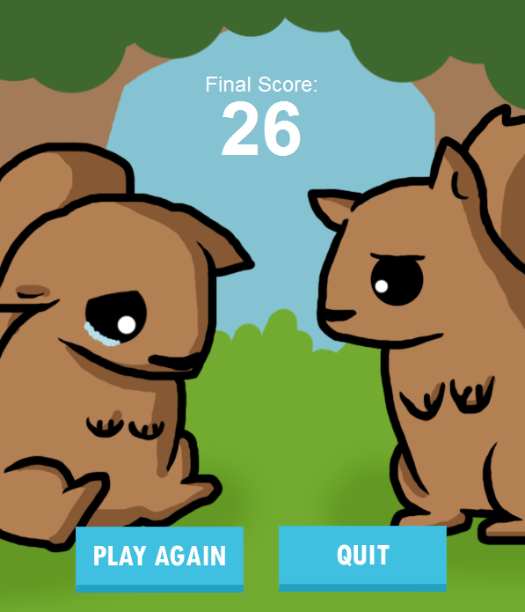

Sad ending screen

In-game screenshot 2